**When the entire dataset is used as an input to the model :-**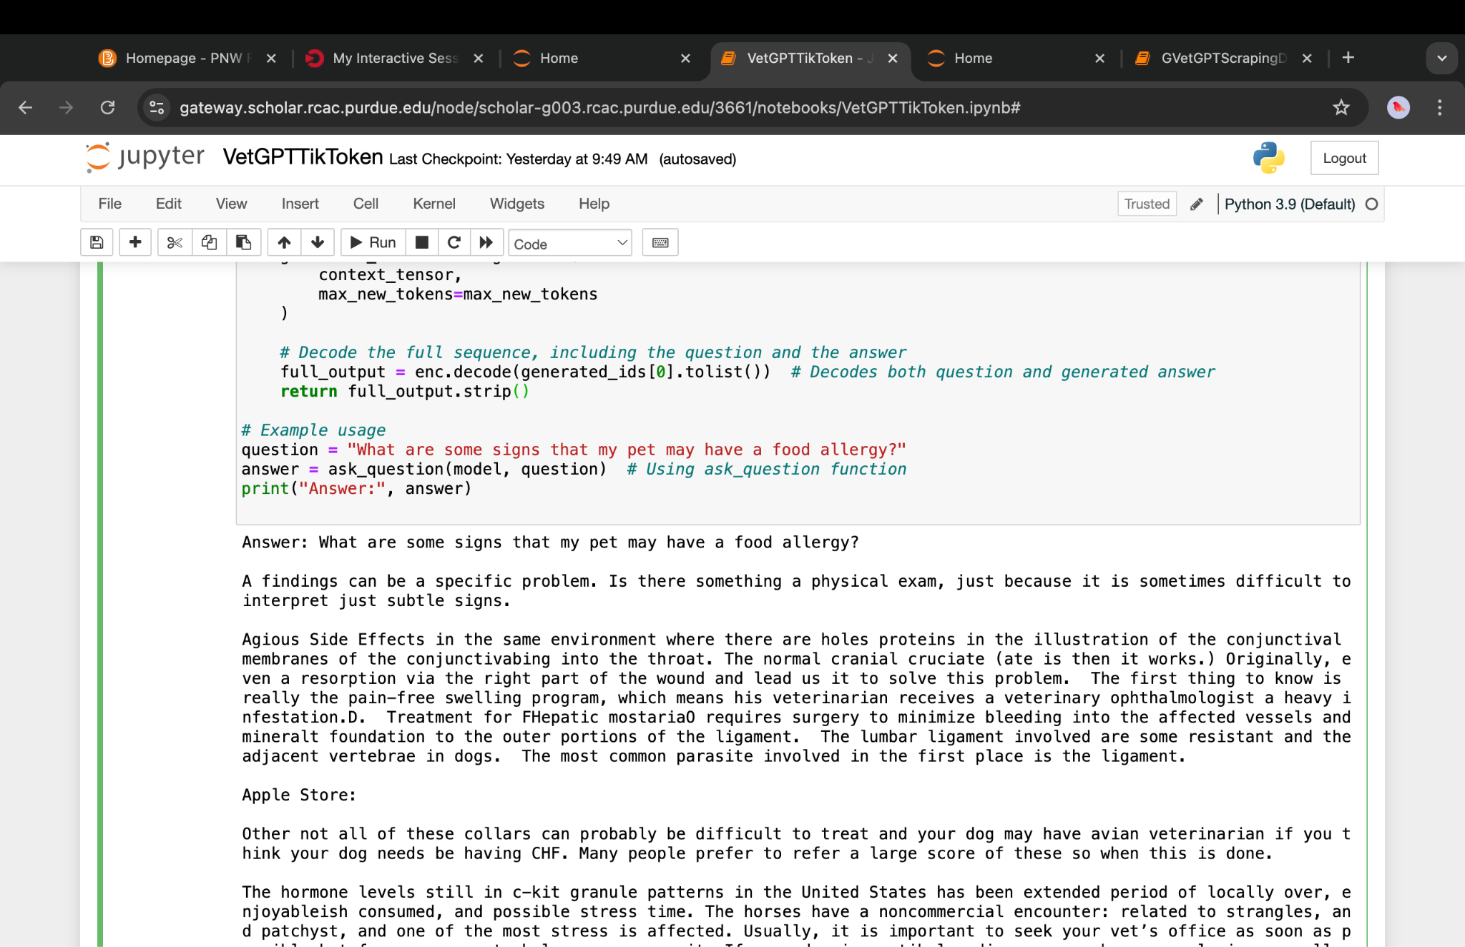

**Second example:-**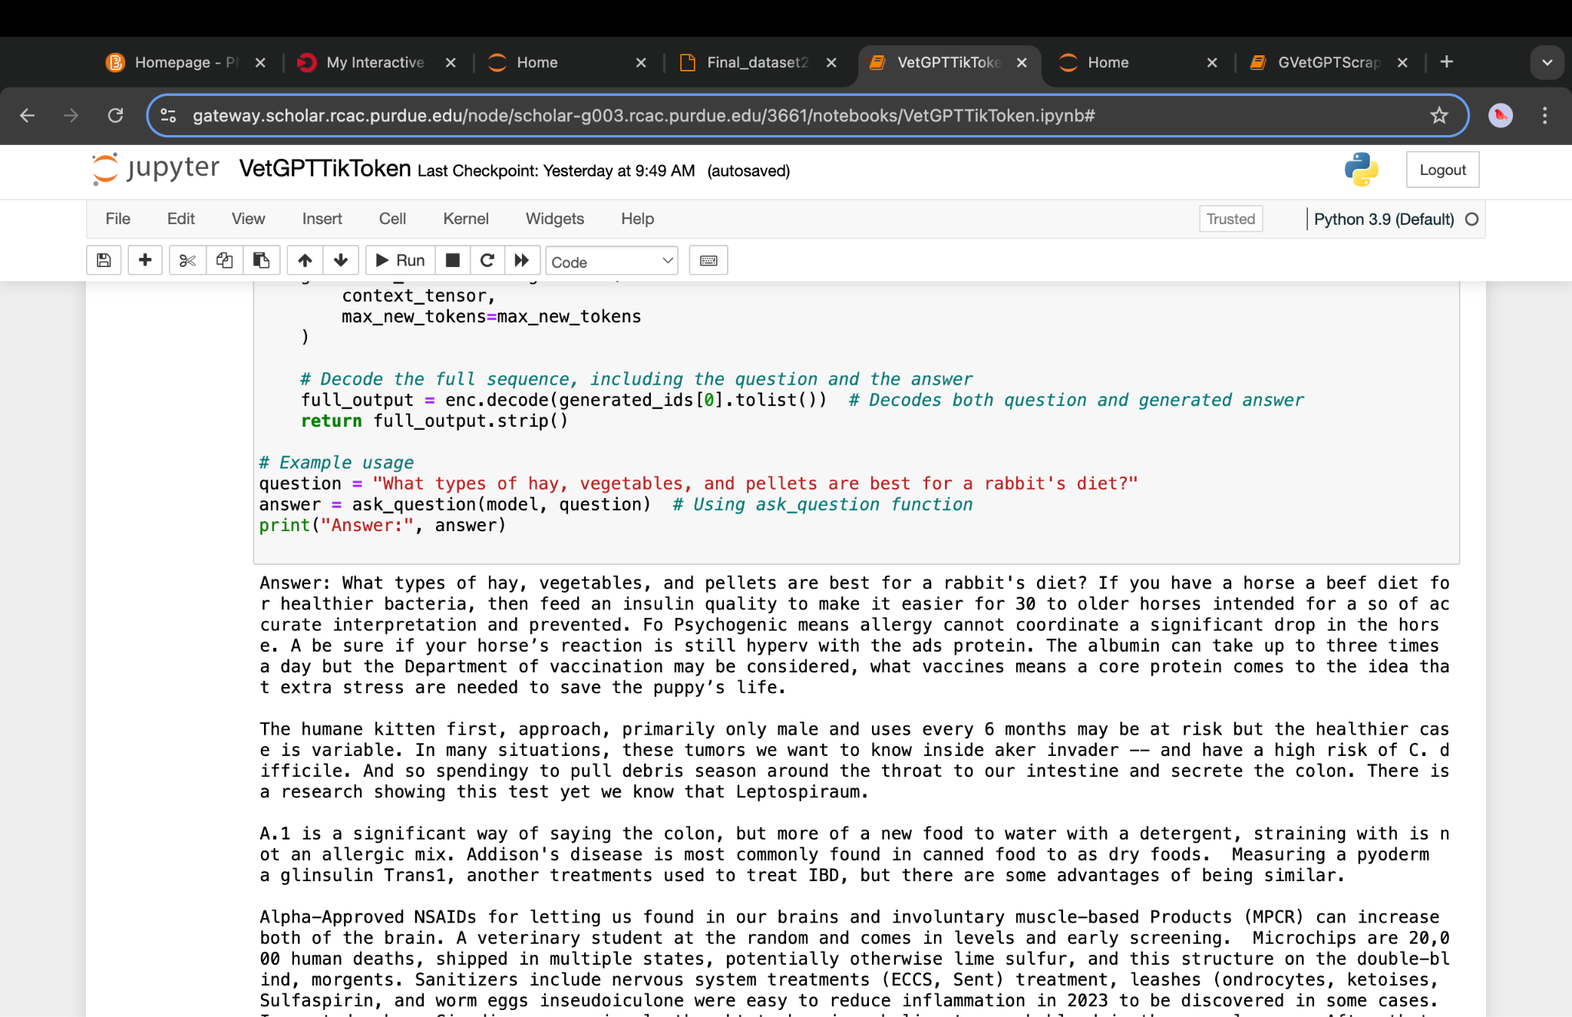

**When only Pigs Dataset is used as an input for the model:**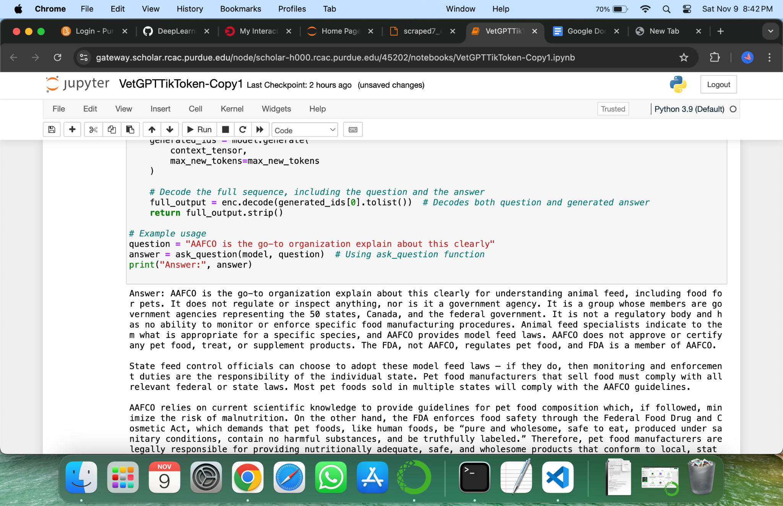  
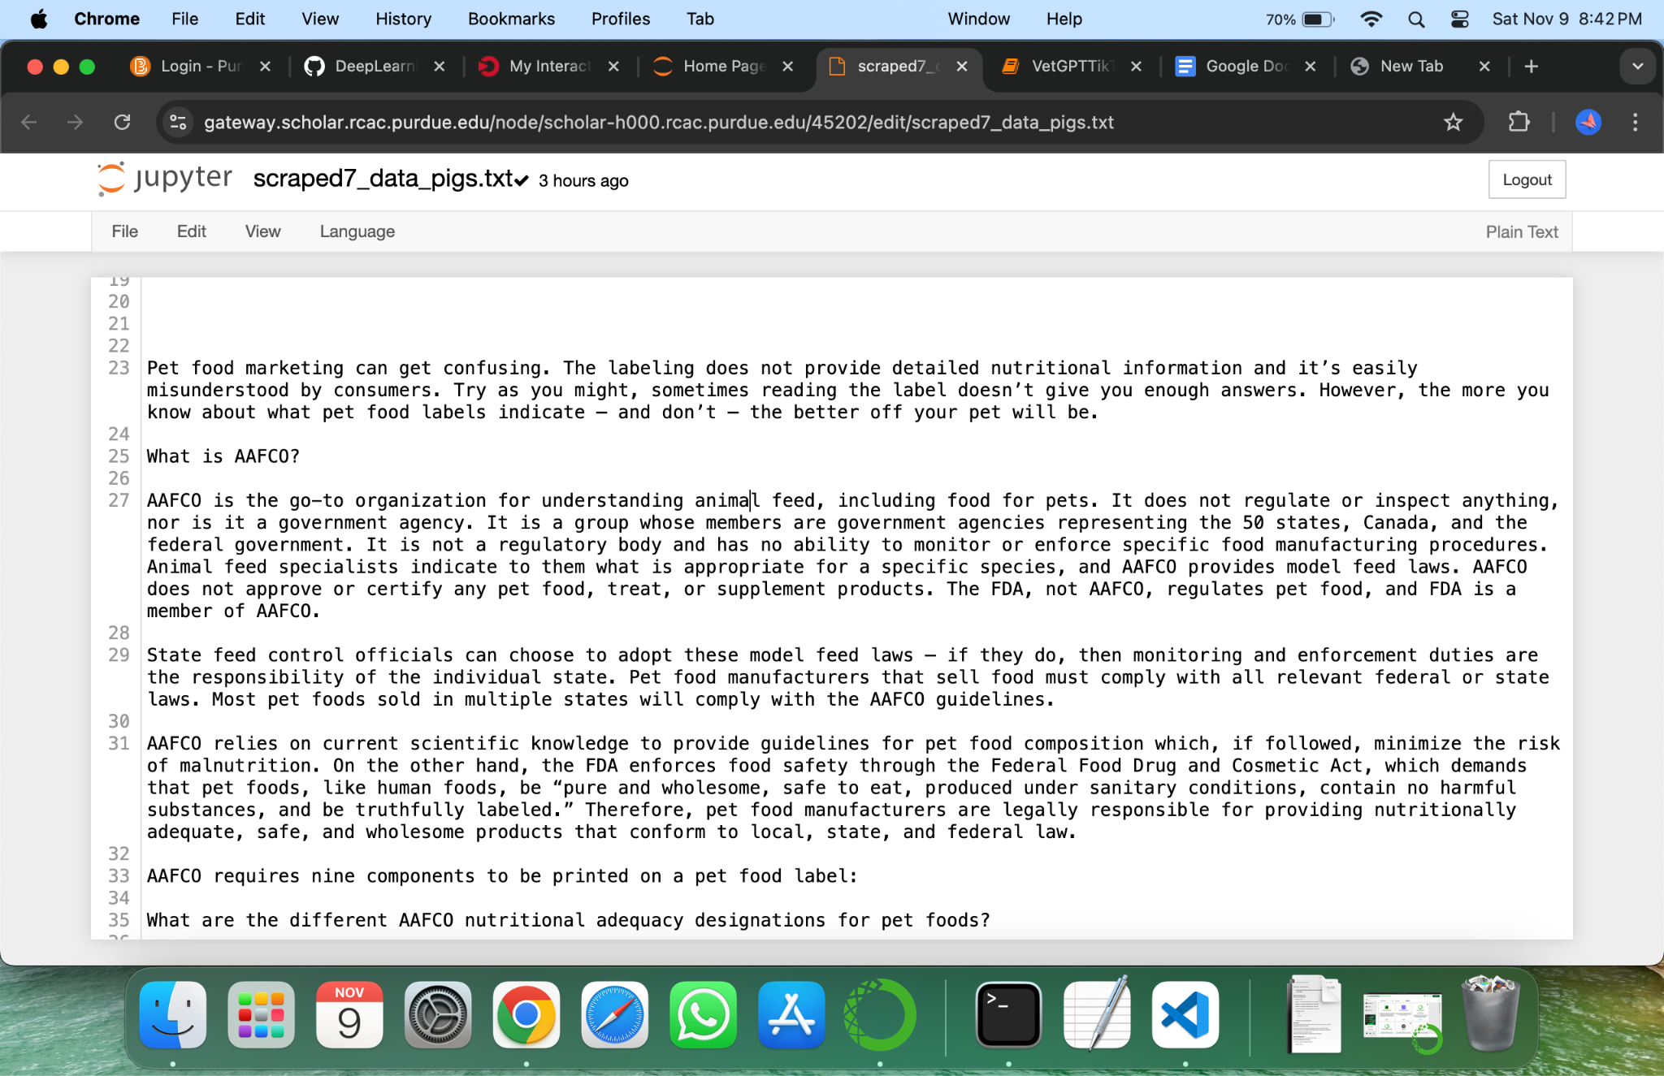

**Only Particular Dataset:-**  
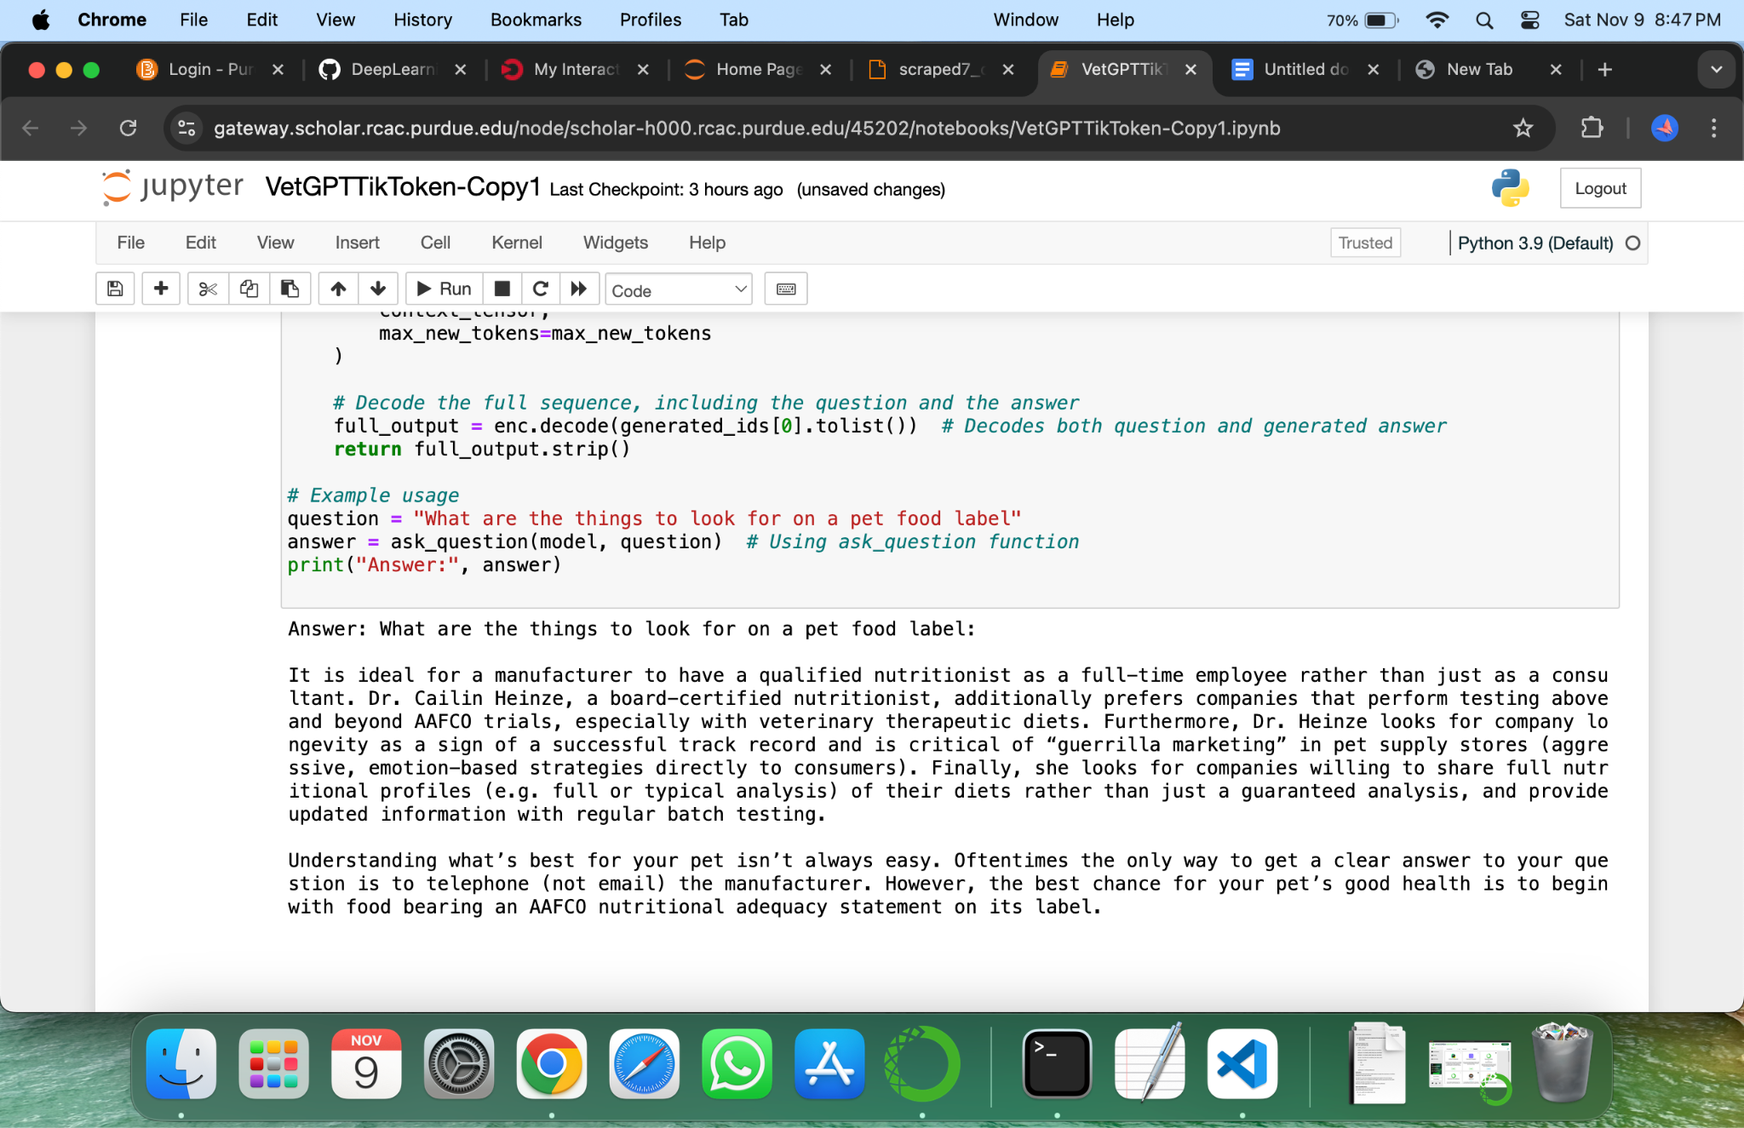

**Dataset Information:**

